3.2 - Labs (2)

* **Lab 3.2.12 (1) Vectors and pointers: first try [A]**

#include <iostream>

using namespace std;

int main()

{

setlocale(LC_ALL, "RUS");

int vector[] = { 3, -5, 7, 10, -4, 14, 5, 2, -13 }, *m = new int, index;

int n = sizeof(vector) / sizeof(vector[0]);

*m = 1000;

for (int i = 0; i < n; i++)

if (vector[i] < *m)

{

*m = vector[i];

index = i + 1;

}

cout << "Самый маленьких элемент: № " << index << "(" << *m << ")" << endl;

delete m;

return 0;

}

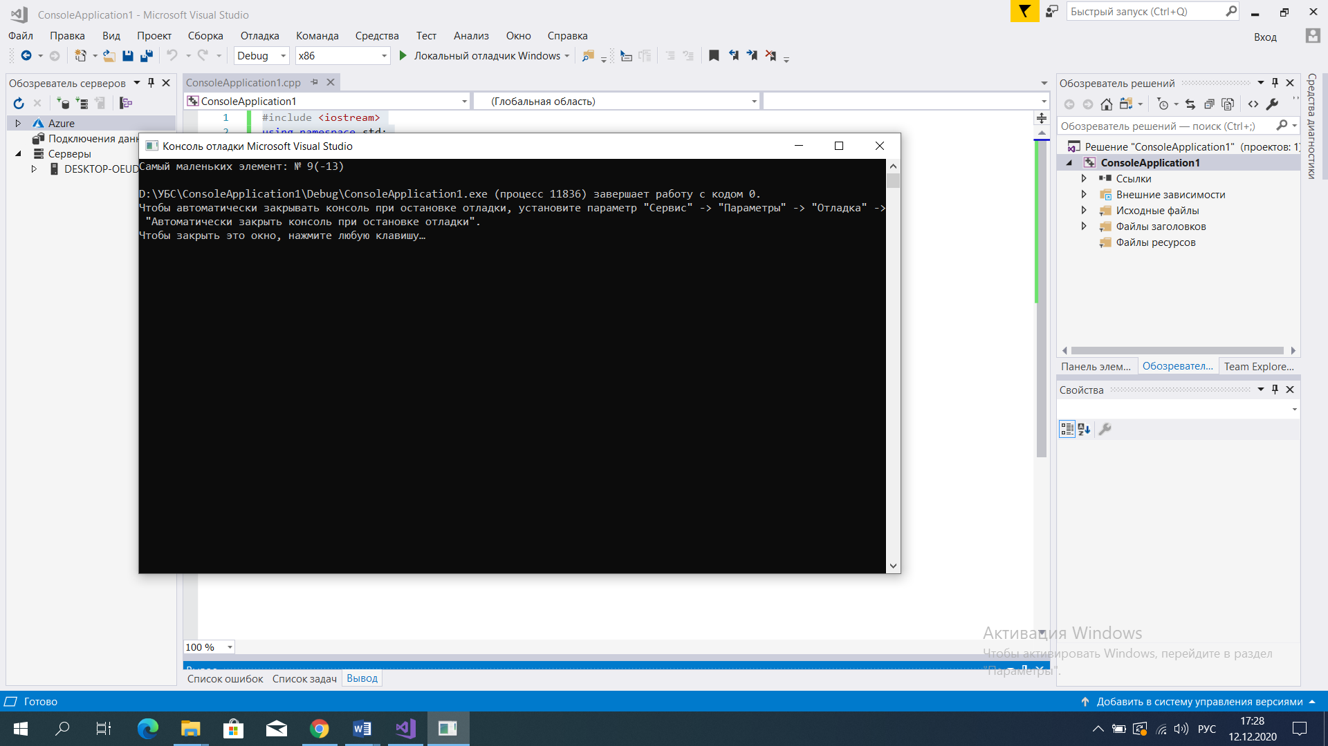

* **Lab 3.2.12 (2) Matrices and pointers - a step inside [B]**

#include <iostream>

using namespace std;

int main()

{

for (int i = 1; i <= 10; i++)

{

for (int j = 1; j <= 10; j++)

{

cout.width(4);

cout << i * j;

}

cout << endl;

}

return 0;

}

